**LAB TASK 6**

**1) Quicksort**

#include <stdio.h>

void swap(int* a, int* b) {

int temp = *a;

*a = *b;

*b = temp;

}

int partition(int arr[], int low, int high) {

int pivot = arr[high];

int i = low - 1;

for (int j = low; j < high; j++) {

if (arr[j] <= pivot) {

i++;

swap(&arr[i], &arr[j]);

}

}

swap(&arr[i + 1], &arr[high]);

return (i + 1);

}

void quickSort(int arr[], int low, int high) {

if (low < high)

{

int pi = partition(arr, low, high);

quickSort(arr, low, pi - 1);

quickSort(arr, pi + 1, high);

}

}

void printArray(int arr[], int size) {

for (int i = 0; i < size; i++)

printf("%d ", arr[i]);

printf("\n");

}

int main() {

int arr[] = {10, 7, 8, 9, 1, 5};

int n = sizeof(arr) / sizeof(arr[0]);

printf("Original array:\n");

printArray(arr, n);

quickSort(arr, 0, n - 1);

printf("Sorted array:\n");

printArray(arr, n);

return 0;

}

}

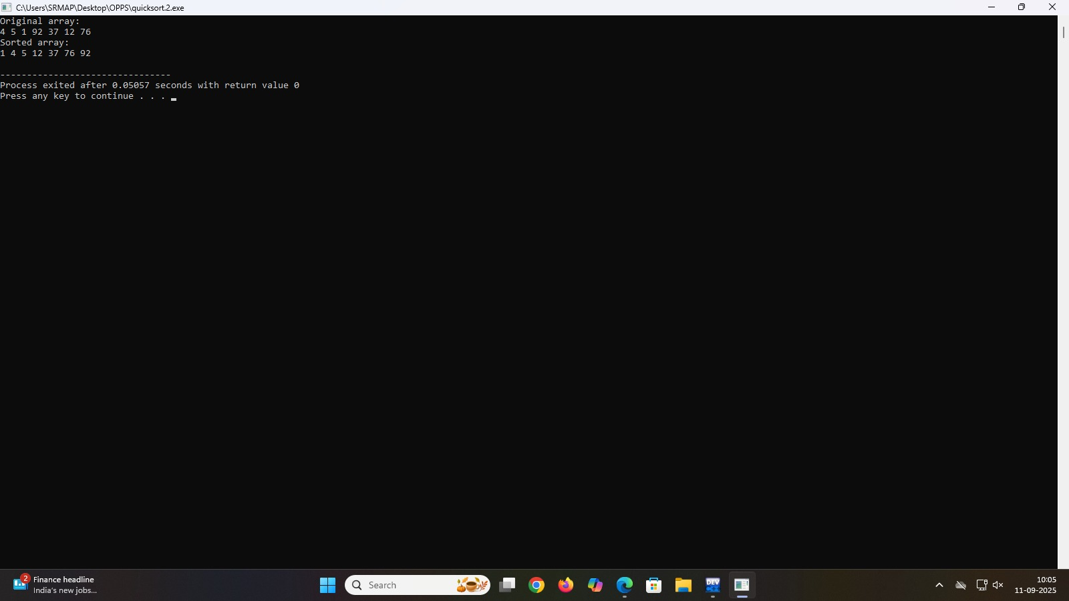

**2)**

#include <stdio.h>

void strassen2x2(int A[2][2], int B[2][2], int C[2][2]) {

int M1 = (A[0][0] + A[1][1]) * (B[0][0] + B[1][1]);

int M2 = (A[1][0] + A[1][1]) * B[0][0];

int M3 = A[0][0] * (B[0][1] - B[1][1]);

int M4 = A[1][1] * (B[1][0] - B[0][0]);

int M5 = (A[0][0] + A[0][1]) * B[1][1];

int M6 = (A[1][0] - A[0][0]) * (B[0][0] + B[0][1]);

int M7 = (A[0][1] - A[1][1]) * (B[1][0] + B[1][1]);

C[0][0] = M1 + M4 - M5 + M7;

C[0][1] = M3 + M5;

C[1][0] = M2 + M4;

C[1][1] = M1 - M2 + M3 + M6;

}

int main() {

int A[2][2] = {{4,5}, {6,7}};

int B[2][2] = {{8,9}, {2,3}};

int C[2][2];

strassen2x2(A, B, C);

printf("Result matrix:\n");

for (int i = 0; i < 2; i++) {

for (int j = 0; j < 2; j++)

printf("%d ", C[i][j]);

printf("\n");

}

return 0;

}

